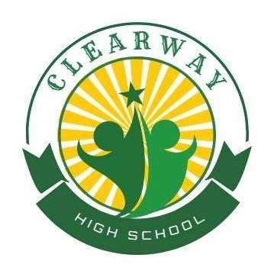**Clearway High School**

**40 Arlington St.**

**Nashua, NH 03062**

**(603) 598-8303**

# **Parent/Guardian Consent for Release of Information**

In order to provide the best care for your child, it is important Clearway leadership and representatives from your child’s home school district are able to exchange information. This may include records such transcripts, immunization records, conduct history, attendance records, as well as current courses and assessments. The information shared will help to determine your child’s eligibility for enrollment at Clearway High School. If you have any questions regarding this release, please contact Clearway Director, Sharon Wilson by email, [SWilson@NashuaALC.org](mailto:SWilson@NashuaALC.org) or by calling (603) 598-8303.

I, the undersigned ______________________, am the parent or legal guardian of the student, (Parent/Guardian Name)

________________________. I grant permission for personnel at (Student Name)

_________________________________ to exchange information regarding my child with

(Home School District Name) Clearway High School.

Student Name: _____________________________________

Name of Parent/Guardian: ____________________________

Street Address: ________________________________ City: _______________ Zip: ________

Email Address: ________________________________ Phone: ______________________

_______________________________________ _______________________

Parent/Guardian Signature Date

Clearway High School

Parent/Guardian Release of Information

July, 2025